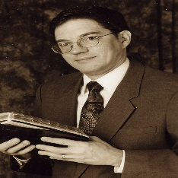
to the global internet. All this has been done for the past twenty plus years while I have been concurrently working 50 hours a week at a secular job to support my family (I Tim. 5:8). Praise God for His strength to carry on!
Christian Answers became an official entity, recognized by the state of Texas and the federal government (for tax purposes), in 1994 following years of my having served with other ministries such as Dayspring Evangelism, The Believer’s Guide magazine, and The Research and Education Foundation. All during this time I felt the most effective method of missionary evangelism was the application of a deep and proper knowledge of God’s word combined with the skillful use of Christian apologetics (Jude 3, I Peter 3:15, Titus 1:9) to refute the “gainsayers” in order to bring glory to God and salvation to men.
The Apostle Paul constantly exhorts Christian believers to not only hold on to sound Biblical doctrine but to “apologetically” teach it to others (II Tim. 3:15-17, I Tim. 1:3-4, 10, I Tim. 4:6,13,16, II Tim. 3:2-5). This is why Christian Answers has such an array of apologetic material on so many subjects, so that the Christian evangelist can take the “two-edged sword” of God’s word (Heb. 4:12) into spiritual battle against any false prophet religion whether it be cultic movements such as the Jehovah’s Witnesses or Mormons to world religions such as Islam or Hinduism. Likewise this missionary evangelism approach

(continued on page 2)
scriptures that Jesus was Christ” (Acts 18:21), as Jeremiah stood against the false prophets of Israel (Jer. 23 & 28) and as did other Old Testament prophets, I found that circumstances are the same here as they were then, the God of the Bible is not wanted.
If a man wants to be true to the word of God with an honest and sincere heart, then he must be ready to deal with all types of opposition from not only the non-religious and pseudo-religious crowd but the “devout persons” crowd which come in every conceivable religious flavor. I’ve often said that “church people” can be the greatest adversaries to Biblical truth because they (if they are not spiritually “born again” as Jesus says must take place, John 3:3-8) do not base their beliefs and faith in God on the Scriptures but rather on their church traditions (Matt. 15:3-6) and personal preferences. The Gospel accounts, for instance, clearly show that that it was “church people” (the Jews in this case) who turned Jesus over to be crucified by the Romans (John 19:11). Satan indeed uses religion as a weapon in a big way in his war against the living God and the souls of men.
Christian Answers came into being as of a result of a true love for God and His word and a deep desire to see God’s truth proclaimed by whatever means possible. What started back in 1981 as a simple tract ministry with typewritten handouts and a street corner evangelism operation has now grown to cable access television outreach, a newsletter mailing list of over 2,500, public speaking opportunities and two websites (www.biblequery.org and www.muslimhope.com) that connect

“exhort in sound doctrine and refute those who contradict” (Titus 1:9)
Larry Wessels
Director, Christian Answers

THE ORIGINS OF
CHRISTIAN ANSWERS
Since my conversion to Christ in 1981 I have had a passion to preach and teach the Gospel to anyone who would listen, whether they were true Christians, nominal Christians, cultists, atheists or religious pagans. I have always been inspired by the missionary zeal of the New Testament apostles and the firebrand nature of the Old Testament prophets. I understood personally what was meant when the prophet Jeremiah declared “...His [God’s] word was in mine heart as a burning fire shut up in my bones, and I was weary with forbearing, and I could not stay.” (Jer. 20:9).
It did not take me long in the Christian life to realize that preaching the Gospel to the American public was like experiencing a page from the Book of Acts, particularly Acts chapter 17. Just as the Apostle Paul noticed that Athens was “wholly given to idolatry” (Acts 17:16), full of religious people (verse 17), and know-it-all philosophers (verse 18), I noticed the same similarities in this society. In fact, as Paul “disputed with the Jews, and with the devout persons...daily” (Acts 17:17), as Apollos “mightily convinced the Jews , and that publicly, showing by the

CHRISTIAN ANSWERS
OF AUSTIN, TEXAS
What Has Been Going On With Us Lately?

SPECIAL MINISTRY UPDATE EDITION Volume 3, Number 1

Special Ministry Update
2

also works with Joe the neighbor next door who has no organized religion and bothers little with God.
Knowing what men (cultists, pagans, etc.) believe about God and the Gospel of Jesus Christ is a key to reaching them with accurate Biblical doctrine that may result, by God’s mercy and grace, in their coming to a saving knowledge of the Savior. For the Christian believer, knowing how to deal with each individual “devout person” religionist on their level is surely a positive prescription endorsed by Paul in I Corinthians 9:19-23. This is one reason why this ministry operates the way it does. Christian Answers offers copies of its many television and radio shows, literature, etc. on many topics and religions to not only Christians who want to learn more and become stronger evangelists for Christ but to non-Christians and inquirers who want to know more about the claims of the Christian faith. In this way, we (let me not fail to mention Steve Morrison, our Director of Research who diligently works with me in this evangelical outreach, despite also working a full-time secular job to support his wife and four kids) are confident that God’s word is being put forth to edify believers and bring Christ’ message to lost souls.
While neither Steve or I is what you would call a “big shot bookstore author with 20 or more book titles to our names, we do count it all joy that God has mercifully allowed us to have a ministry which has reached so many thousands of lives. This just goes to show that if a man loves Christ and has a strong desire to serve Him despite his circumstances, God can make a way. Praise the Lord (Psalms 117, 136)!

MINISTRY UPDATE NEWS
TELEVISION OUTREACH

As many of you already know, I have been a cable access television producer since 1985, and of course, this has been the genesis of all the Christian videos we have produced. Many cities across America provide free television access to local residents and all that is required is that local residents take a few access television classes. Once the access classes are completed (they generally take about four weeks, two 90-minute classes a week) the successful graduate is ready to

produce and air television programs for virtually no cost in his city. Since God was gracious enough to provide the opportunity in Austin, Texas I naturally took advantage of it. We have never failed over all these years to preach the Gospel through this medium and have encouraged others to join with us in this endeavor, specifically access in other cities.
One of our supporters recently completed required access training in Dallas, Texas and will soon be airing Christian Answers videos in that major media market for a yearly producer fee of $375 ( the fee would have been lower if our producer actually lived within the city limits of Dallas). Exciting opportunities to expand to other nearby cable access cities also exist.
If you are interested in putting our Christian Answers videos on your local cable access channel where you live, just find out what your particular cable access television station requires (as far as classes, etc.), complete the requirements, then give us a call (512-218-8022) and we’ll work with you on providing videos on the subject of your choice. What an inexpensive way to reach thousands of viewers! I remember going door-to-door in neighborhoods preaching the Gospel (a lot of people thought I was a Mormon or a Jehovah’s Witness) and I would literally spend hours and hours reaching only a comparatively small group of people, but with Austin’s free cable access television I could suddenly reach infinitely more people in a lot less time (400,000 households are connected to cable television in this geographic area).
Currently viewers in Austin can see “Christian Answers” in its new series slot time, on Saturdays from 10:00 AM to 11:00 AM on Time Warner cable access channel 11. The live call-in show, “In Defense of the Faith,” airs on Friday nights from 7:00 PM to 8:00 PM. Various Christian Answers programs are aired randomly throughout each broadcast week. During October of this year, a special three-hour live broadcast of “In Defense of the Faith” was held.
Furthermore, if you have a doctrinally sound ministry and are interested in producing your own professional videos for your own ministry, please

give us a call. Most of our Christian Answers videos have been professionally produced by Digital Media Productions here in Austin. Digital Media Productions has been producing high quality videos for various Christian ministries for years. The length of your video projects, on-site locations, as well as the costs can be discussed in detail.

LATEST RESEARCH PROJECTS

Back in December 2001 our ministry received a one-time, never to be repeated, unsolicited donation of $10,000 from an individual that we did not personally know. Most of the donations to this ministry are very few and generally very small, hence our budget is very limited. Yearly video and audio sales generally average around $3000 -$4000 and donations from the public amount to much less than that. Consequently, Steve and myself receive no salary or pay for what we do (that’s why we work full-time secular jobs) because the finances of Christian Answers simply cannot help us support our families. Therefore, to receive such a large one-time gift enabled us to invest in new research and video production.
Over the course of the years 2002 and most of 2003, thanks to the large donation, we were able to produce quite an array of new research videos packed with power point graphics on the subject of Islam. From this considerable volume of videos we plan to create our first written books (Steve’s on the main subject of Islam, while my book will be entitled, Answering Islamic Apologists), as well as pamphlets and booklets, scheduled to come out, by God’s grace, sometime next year. Please see page 5 for a complete listing of these new videos along with other new materials not listed in our old ministry resource list (page 6).

Larry Wessels & Steve Morrison in
studio during the ten-hour video series,



(continued on page 3)
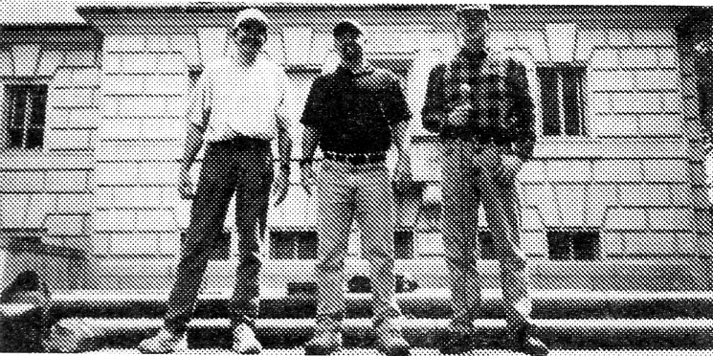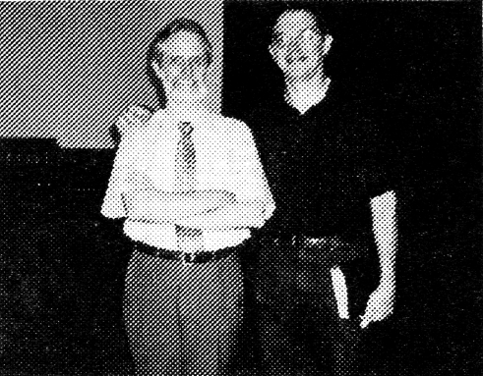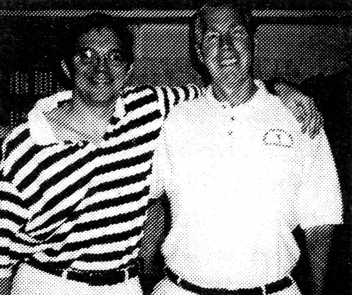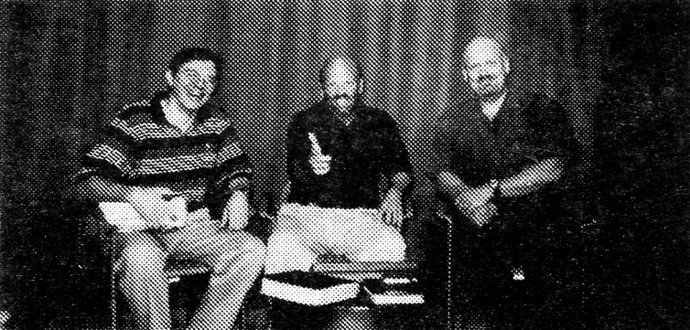
One last note on this point if you don’t mind. Over the last several years (even before Sept. 11, 2001) Steve Morrison, who does have a Ph.D. by the way, has done extensive and primary research into the subject of Islam on various levels and the videos we have produced reflect this. Steve’s current website www.muslimhope.com will prove to anyone what I am talking about. One of the outstanding features of the website is Steve’s reference index of the Sunni hadiths and the Quran which is based on his own personal reading of all the authoritative Muslim hadiths translated into English including Sahih Muslim, Al-Bukhari, Ibn-I-Majah, Abu Dawud, Nasa’i etc.

NEWSLETTER UPDATE

Our next Christian Answers newsletter is virtually finished and will be on the subject of “Spiritual Warfare.” The one after that will be “Seventh-Day Adventism.” We have not put out a topical newsletter this year because I decided to devote all of our available finances to the production of the afore mentioned Islam videos. It costs approximately $1100 to print and mass mail each newsletter ($665 to pay the printer and $400 to $500 for postage). When we have enough funds for this it will be sent to our entire mailing list, foreign and domestic, free of charge.
RECENT EVENTS

University Outreach

Larry Wessels, Dale Delony, host of “In Defense of the Faith,” and Steve Morrison on the steps of the Texas Tower at the University of Texas campus.

Our periodic evangelistic excursions to the University of Texas campus here in Austin have now been going on for more than 10 years (22 years if you count all my individual preaching trips

3
to the campus since I graduated from there). Generally each semester a campus student group will sponsor us to come speak using the university public address system on the West Mall of the campus from the steps of the famous Texas Tower. Usually we are given two hours to speak and interact with students, teaching assistants and professors, over the course of two or more days. As can be imagined, the reaction from the college crowd is generally skeptical and hostile to the Christian message. In this particular case, the first day we debated Muslim students, New Agers, and Agnostics; the second day was mainly an ongoing debate concerning the atheistic concept of the theory of evolution versus special creation of the universe by the living God of the Bible. Christian Answers has a few of these campus expeditions recorded on video and available through our resource list (my favorite is with Dr. Michael Girourd, see VT-3 entitled, “Creationism Discussion at the University of Texas,” $6.00 + S&H).

OUTREACH TO CATHOLICS

Richard Bennett and Larry Wessels at Dayspring Chapel in Austin, Texas.

Richard Bennett, who was a Dominican priest for 22 years before his conversion from Roman Catholicism to Christ, has joined my church fellowship here in Austin. It is exciting to have a bold brother in the Lord fighting “the good fight of faith” (I Tim. 6:12) by every means possible. Richard has compiled and edited such books as Far From Rome, Near to God: The Testimonies of 50 Converted Catholic Priests, and The Truth Set Us Free: 20 Former Nuns Tell Their Stories; he is the editor and main writer for the national newsletter the Berean Beacon; he actively engages in public speaking tours; and his ministry (just like ours) produces public access television prog-

-ramming to reach Catholics for Jesus Christ. Richard has generously allowed our ministry to market many of his videos, audio cassettes, and written literature –see page 6 of this newsletter for examples. Richard’s website is www.bereanbeacon.org and his mailing address is: Berean Beacon, P.O. Box 192, Del Valle, TX 78617-0192.

Larry Wessels and Rob Zins in the Christian Answers office. Rob came by Austin for a visit during the Spring.

Another excellent Christian apologist dealing with the Roman Catholic system of religion is brother Rob Zins who has his Master of Theology degree from Dallas Theological Seminary and is Director of A Christian Witness to Roman Catholicism (CWRC). Rob is the author of Romanism and On the Edge of Apostasy, along with numerous articles and pamphlets (Rob’s books, like Richard Bennett’s are available through Christian Answers). Rob in fact, wrote the lead article for our very first Christian Answers newsletter and appeared with me in the 16-hour video series on Roman Catholicism (VT-18, 8 VHS tapes, $48 + S&H). Rob also has an informative quarterly publication called Theo-Logical. For more information, contact Rob at CWRC, P.O. Box 325, Herndon, VA 20172-0325.
JAMES WHITE VISIT

Larry Wessels, Dale Delony, & Dr. James White appear on the live call-in broadcast, “In Defense of the Faith” in the Austin Access television studio.

Special Ministry Update
(continued on page 4)


4
Special Ministry Update

Only Controversy.” The proper e-mail address to reach Bob L. Ross, director of Pilgrim Publications (one of the world’s leading publishers of C.H. Spurgeon) is pilgrimpub@aol.com. Bob and his son have always been like actual family to me (see our resource list for all the numerous videos, audios and books by Bob on different subjects).
By the way, as a reminder, Gary Hudson’s website is www.kjvonly.org. Gary is an expert on the KJV controversy and is a very good singer (check out his musical CDs by e-mailing him at HudsonGhdsn@aol.com).
DUNGEON WORK

Producer Steve Metz directs his camera man, (right) Metz interviews Larry Wessels and David Krill on fantasy role games.
A few months ago a college instructor named Steve Metz requested a videotaped interview with me for a video documentary he was producing concerning Fantasy Role Playing games. Before my conversion to Christ I had been playing Dungeons and Dragons (much of it based on “The Lord of the Rings”) throughout the 1970s and into the early 1980s. I had even progressed to becoming a Dungeon Master of a weekly game involving up to 14 players with sessions lasting past 12 hours.
The video interview lasted three hours, which included commentary by David Krill, and a copy of the raw footage was provided to our ministry. When funds allow, we will edit this footage into a video series exposing the anti-Biblical and evil nature of this game as well as other “games” similar to it.
SECULAR WORK

This is for our readers who may have special needs in the business field. Steve Morrison is a C# and C++ software developer, who has experience in custom code generators, writing scheduling software, and SQL Server Database

where you will find some of Dr. White’s latest lectures and debates.
I have many of Dave Hunt’s books and tapes and have always loved Dave as a bother in the Lord and still do. Dave has appeared before on our “In Defense of the Faith” telecast and I have even provided him with a free copy of my televised debate with Roman Catholic scholar Dr. Robert Fastiggi (Reformation Debate, VT-5), at his request, before his own debate with the same. I must respectfully disagree with Dave’s Arminian views of God’s grace, while at the same time, I agree with Dr. White’s soundly Biblical views.
I have edited and compiled two short papers on this subject myself entitled, “The Doctrines of Grace” (Pack-3, $2.00) and “How Sovereign Is God?” (Pack-7, $2.00), and have produced a six hour video series concerning this with author and publisher Bob. L. Ross (an expert on the theology of Charles H. Spurgeon) entitled, “The Biblical Doctrine of Predestination” (VT-41, $18.00). I must take issue with Dave here. Dave’s emotion filled arguments and confessed claims of ignorance of Reformed literature out of his own mouth can be found on the radio tape entitled, “Is Calvinism Biblical? Debate” with Dr. White (AC-287, $3.00 + S&H). This Hunt-White exchange is truly amazing and perhaps led to Dave’s book on this subject a very suspiciously short time later.
I highly recommend James White’s ministry to our readers. Dr. White is director of Alpha & Omega Ministries, P.O. Box 37106, Phoenix, AZ 85069; his website is : www.aomin.org.

CORRECTION

Bob L. Ross, son Mike, and Larry Wessels at the Christian Booksellers Convention.

We regret that there was a typo in our Christian Debater Guide, volume 2, number 4, dealing with the “King James

Taking nothing away from my dear brothers in the Lord, Richard and Rob, I must say without hesitation that I believe one of the best Christian apologists dealing with multiple subjects in America today is author and speaker Dr. James White. James has written numerous books including The Forgotten Trinity, Letters to a Mormon Elder, The Fatal Flaw, The King James Controversy, The God Who Justifies, Mary– Another Redeemer?, and many others. He has also written articles for our Christian Answers Journal as well as many other publications such as the C.R.I. Journal. James has done more public debates concerning Biblical issues than any other man I know of, living or dead, and I praise God for such a soldier for Christ’s truth as this.
I had the pleasure of seeing James at a Bible conference in San Antonio, TX during the Spring. I had the opportunity to work with him in a live television broadcast during his recent visit to Austin in the Fall. The last time I appeared on television with James was during the mid-1990s when we recorded several videos together including Evidence That Jesus Is God (VT-36), Sola Scriptura (VT-35), and New Age Bible Versions Refuted : The Video (VT-2).
Dale Delony, director of Peaceway Productions (another Christian evangelical ministry located in Austin) and host of the live call-in telecast called “In Defense of the Faith” and myself, the co-host/guest on the show for the last 13 years, invited Dr. White to participate with us. James did a great job of answering caller’s questions and presenting the evidence for the Christian faith. David Krill, who normally appears on the broadcast, graciously sat out to let James participate.
James mentioned that one of his upcoming books will be co-authored by Dave Hunt on the subject of Calvinism. The book will actually be a debate book with James defending the historic doctrines of the Reformed faith based on a hermeneutical approach to scripture while Dave will be arguing for the Arminian view of salvation based on his understanding as presented in his book, What Love is This? For those of you who are interested in this Calvinism versus Arminian debate on salvation, please see pg. 6 of this newsletter

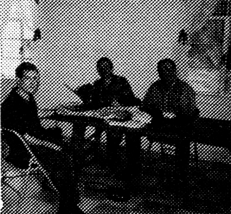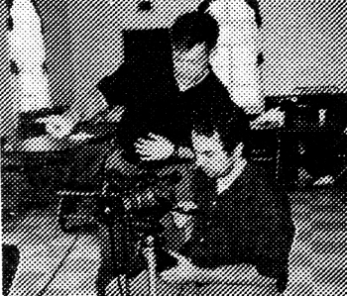

(continued on page 6)
5

SPECIAL ANNOUNCEMENTS!
PRICE CUTS ACROSS THE BOARD AND NEW MATERIALS!
For years Christian Answers has had the same prices for audio cassette and video cassette ministry resources. For example, in the past a single audio cassette purchased from this ministry would cost $5.95 and a two tape audio cassette series would cost $9.90. Likewise, video cassette pricing ranged from $15.00 for a 2-hour VHS series (one VHS tape), $25.00 for a 4-hour VHS series (two VHS tapes), $30.00 for a 6-hour VHS series (three VHS tapes), and up to $90.00 for a 16-hour VHS series (8 VHS tapes). These prices were set to help this ministry financially and no further consideration was given to this for nearly a decade.
However, following a sincere desire to “Go ye into all the world, and preach the gospel to every creature” (Mark 16:15), our ministry would like to make our resources more affordable. Therefore, all audio cassettes currently listed in our present resource list and sales flyers are now reduced to $3.00 per audio cassette. If someone orders five audio cassettes of any title, the cost will be $15.00 plus shipping and handling. Pricing for VHS tapes are also drastically reduced. A standard price of $6.00 per VHS tape is now in effect. For example, if someone purchases a 6-hour VHS series (3 VHS tapes, 2 hours on each VHS) the final cost will be $18.00 plus shipping and handling. A 16-hour VHS series (8 VHS tapes) would be $48.00 plus shipping and handling instead of the previous $90.00. These nearly 50% price cuts will make every dollar count.
We sincerely hope that these price reductions will encourage more of our Christian brothers and sisters to purchase resources so that they can use them for their own benefit and also to share them with others in this lost and dying world. “Redeeming the time, because the days are evil” (Eph. 5:16).
New Videos and Soundtracks On Islam
1) Understanding Muslims and the Islamic Faith (VT-82, 4hrs)
(Steve Morrison and Larry Wessels)
Understanding Muslim Minds
Understanding Muslim Hearts
Proving that Jesus is God
Jesus, Mohammad and Fatherhood
Price: $12.00, VHS.
Audio cassette soundtracks of the same video series:
AC-277- Understanding Muslim Minds: $3.00
AC-278- Understanding Muslim Hearts: $3.00
AC-279- Proving that Jesus is God: $3.00
AC-280- Jesus, Mohammad and Fatherhood: $3.00
Entire audio series: $12.00.
2) The Sects of Islam Series (VT-83, 5 hours)
(Steve Morrison and Larry Wessels)
Various Muslim Factions
Sunni Muslims
Shi’ite Muslims
‘Alawite Muslims
Sufi Muslims
Price: $15.00, VHS.
Audio cassette soundtracks of the same series:
AC-322- Various Muslim Factions: $3.00
AC-323- Sunni Muslims: $3.00
AC-324- Shi’ite Muslims: $3.00
AC-325- ’Alawite Muslims: $3.00
AC-326- Sufi Muslims: $3.00
Entire Audio Series: $15.00.
3) Personal Testimony of Islamic Culture
and Persecution (VT-84, 2 hours)
(Rev. Saleem Masih and Larry Wessels)
Thirty-three Years in Pakistan
Islamic Oppression
Price: $6.00, VHS.
Audio cassette soundtracks of the same video series:
AC-275- Thirty-three Years in Pakistan: $3.00
AC-276- Islamic Oppression: $3.00
Entire Audio Series: $6.00.
4) The Daughters of Allah (VT-85, 1 hour)
(Steve Morrison and Larry Wessels)
Price: $6.00, VHS.
Audio cassette soundtrack of the same video:
AC-327- The Daughters of Allah: $3.00

5) Islamic Holy War– Jihad (VT-86, 1 hour)
(Steve Morrison and Larry Wessels)
Price: $6.00, VHS.
Audio cassette soundtrack of the same video:
AC-338- Islamic Holy War-Jihad: $3.00
6) The Sahih Muslim Hadiths (VT-87, 2 hours)
(Steve Morrison and Larry Wessels)
Legalism, Lost Surahs, and Women
Muslim Miscellaneous
Price: $6.00, VHS.
Audio cassette soundtrack of the same video series:
AC-339- Legalism, Lost Surahs, and Women :$3.00
AC-340- Muslim Miscellaneous: $3.00
Entire Audio Series: $6.00
7) Answering Islamic Apologists (VT-88, 10 hours)
(Larry Wessels and Steve Morrison)
Introduction to Islamic Apologetics
Sinlessness of the Prophets of Islam?
Questionable Arguments for the Quran
Quranic Miracle and the Islamic Jesus?
Islamic Attack Against Key Bible Doctrine
F) Islamic “Jihad” Against the Biblical God
G) Muslim Denial of the Trinity and Christ’s Blood
H) Man’s Fallen Nature and Biblical Prophecy
I) More Attacks Against Christianity
J) Biblical Truth vs. Islamic Paganism
Price: $30.00, VHS.
Audio cassette soundtrack of the same video series:
AC-328- Introduction to Islamic Apologetics
AC-329- Sinlessness of the Prophets of Islam?
AC-330- Questionable Arguments for the Quran
AC-331- Quranic Miracle and the Islamic Jesus?
AC-332- Islamic Attack Against Key Bible Doctrine
AC-333- Islamic “Jihad” Against the Biblical God
AC-334- Muslim Denial of the Trinity and Christ’s Blood
AC-335- Man’s Fallen Nature and Biblical Prophecy
AC-336- More Attacks Against Christianity
AC-337- Biblical Truth vs. Islamic Paganism
Entire Audio Series: $30.00

“Study to show thyself approved unto God a workman that needeth not to be ashamed, rightly dividing the
word of truth.” (II Tim. 2:15)

6
Special Ministry Update
NEW ITEMS

James 5:14-15 (“Is any sick among you? Let him call for the elders of the church; and let them pray over him, anointing him with oil in the name of the Lord. And the prayer of faith shall save the sick, and the Lord shall raise him up...). A few hours after Tommy was anointed and prayed over he was taken to the Texas Children’s Hospital in Houston, TX where the physicians, by God’s grace, were able to stop the seizures. From that day on Thomas has never had another seizure although, because of his brain damage, is on the mental level of a 4 month old child. Tommy cannot talk or walk (he travels by wheelchair) and I have been changing his diapers now for 21 years but my wife Diane and I love him dearly.
Our other special child is our 14 year old daughter named Gloria. She was born moderately retarded and now attends special education classes. She can walk and talk and particularly likes to sing. (Matt. 19:13-15).

A PLEA FOR HELP

The Lord’s work throughout the world will easily carry on without a ministry such as ours but I believe the Lord has given each one of us a work to perform in His vineyard. I certainly do not claim to be an eloquent and polished speaker who is worthy of awards from the Toastmasters club (I’m sure Steve Morrison would say the same). Although I have a Bachelor of Science in Advertising degree from the University of Texas at Austin, the only thing I’ve wanted to advertise since my conversion is Jesus Christ and His Gospel. I have tried to help fellow Christians across all denominational lines. I have been invited to speak at independent Bible churches, charismatic churches, Lutheran churches, traditional Baptist churches, Reformed churches, and even, to my great surprise, a United Methodist Church. The Austin Baptist Association has even invited me to speak at their past summer youth camp.
I have always had an aversion to asking the brethren for financial donations because I know they are already burdened down with requests from every direction. However, if you feel you could spare a portion for our ministry efforts it would be greatly appreciated

programming. He has a Ph.D. in chemical engineering and two patents for data analysis related to neural networks. He can be reached at cdebater@aol.com.
On a different note, thanks to Steve’s extraordinary research into Islam, Steve has been invited to speak at George Houssney’s Horizon International summer training school this coming June in Boulder, Colorado. Under the title of “Breaking Islam’s Strongholds,” Steve will be teaching Christian students how to better reach out to the Muslim world.

FAMILY NEWS

Larry Wessels’ daughter Marlena with her two daughters Angelina and Azelia.

I am now a two-time grandfather! Wow, how the time flies (Psalm 90). My oldest daughter Marlena was married to Miles Gauthier three years ago and now suddenly I am blessed with two fine granddaughters, Angelina (6 months) and Azelia (one and a half).

Thomas Wessels Gloria Wessels

I have also been blessed with two special children from the Lord. My oldest son Thomas (21 years old) was born with severe brain damage. Thomas was in critical condition, suffering from and ever increasing frequency of seizures, as a new born infant. The seizures started about 1 to 2 hours apart, however, they increased to within 10-20 minutes apart over the next couple of months. Doctors in Austin and San Antonio were at a loss as to how to stabilize his condition. As Tommy’s condition worsened, I called for my pastor (Jackson Boyett, pastor of Dayspring Chapel here in Austin) and the elders of the church according to

Currently, we are in need of a working copier, a new computer (ours is five years old), equipment that will convert our audio cassettes to CDs and our VHS tapes to DVDs, funds for future video production and TV outreach expansion, general supplies, funds to pay for printing and distribution of upcoming newsletters, books, and pamphlets, and various other needs (note that “salaries” are not included in these needs since we do not get paid anyway).
Our ministry is classified as a non-profit organization, therefore, all financial donations are considered to be tax deductible. Thank you in advance if you can help us but no matter how things turn out, we will, as we have in the past, work within the means that God has granted us (Psalm 56:9-11).

James White
AC-281-282 The Trinity Debate
White vs. Sabin $9.00
AC-284-285 Debate with A Muslim
White vs. Malik $6.00
AC-287 Is Calvinism Biblical?
White vs. Hunt $3.00
AC-291-292 Who Controls Salvation ?
White vs. Bryson $6.00
AC-360-362 “New Perspective” Heresy $9.00
AC-363 The Whole Counsel of God $3.00

Richard Bennett
AC-380 Richard Bennett’s Testimony $3.00
AC-381 The Alignment of Apostasy $3.00
AC-382 The Roman Catholic Mary $3.00
AC-383 Communion: Fellowship $3.00

Rob Zins
AC-370 I’m A Christian $3.00
AC-371-372 Sola Fide Debate $6.00
Zins vs. Matatics
AC-373-374 Sola Scriptura Debate $6.00
Zins vs. Matatics
AC-375-378 Perpetual Virginity of Mary? $12.00
Zins vs. Matatics

Pastor Jackson Boyett
AC-390 Minimum Christianity $3.00
AC-391 Baptism With the Spirit $3.00
AC-395 The Great Tribulation $3.00

Steve Morrison & Larry Wessels
VT-100 Unification Church Debate $6.00
Morrison & Wessels vs.
Erling & Laura Lea
AC-258-259 Unification Church Debate $6.00

In Defense of the Faith (4 hours)
Larry Wessels, Dale Delony, David Krill $12.00
VT-101 Various Topics, “Church of Christ” Debate

Plans are in the works to create an updated resource list but when this will happen is uncertain. We still need to update our ministry products to include conversion to CDs and DVDs .



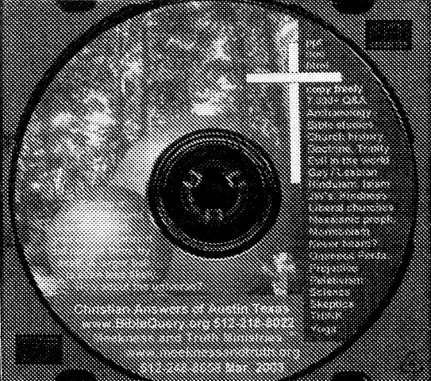

Hear experts and apologists analyze these topics (perfect for study groups). You may choose any four of the 28 minute videos below for the single price of $6.00 + S&H. Catalog identification is CATV. For example, if you wish to order Bahaism, “Church of Christ”, Mormonism, and Islam; list on order form as CATV= 1, 8, 12, and 16. Four videos on one tape for one low price of $6.00+ S&H.

Bahaism (Dr. Frank Beckwith)
Roman Catholicism #1 (Rob Zins)
Roman Catholicism #2 (Rob Zins)
The “King James Only” Cult #1 (Gary Hudson)
The “King James Only” Cult #2 (Gary Hudson)
Seventh-Day Adventism #1 (Wallace Slattery)
Seventh-Day Adventism #2 (Wallace Slattery)
The “Church of Christ” (Bob L. Ross)
United Pentecostals (Steve Morrison)
Word-Faith Heresy #1 (Michael Horton)
Word-Faith Heresy #2 (Michael Horton)
Mormonism (Robert McKay)
Jehovah’s Witnesses #1 (Larry Wessels)
Jehovah’s Witnesses #2 (Larry Wessels)
Nation of Islam (Wilford Darden)
Islam (Dr. Samuel Shahid)

TOPICAL VIDEOS
Special Incentive: If you order $25.00 of material or make at least a $25.00 donation you may choose two of the following audio tapes free ( check preferences) :

Christian Answers Order Form
The Catholic Mary-James White (AC-232)
Eternal Security Debate-Rob Zins vs. Dan Corner (RP-16)
Richard Bennett’s Testimony (AC-380)
IF YOU NEED MORE ROOM PLEASE USE A SEPARATE SHEET OF PAPER.
SUBTOTAL

POSTAGE AND HANDLING

TEXAS RESIDENTS ADD 8.25% TAX

TAX DEDUCTIBLE DONATION

How to place an order with Christian Answers of Austin, TX
1) Please indicate your full shipping/ mailing address.
2) Please include quantity, description and price (minimum order-$5.00).
3) Please make check or money order payable to CHRISTIAN ANSWERS OF AUSTIN, TX
(we can only accept US funds).
4) Mail to : Christian Answers , P.O. Box 144441, Austin, TX 78714.
5) Foreign orders must be paid with an international money order (US funds only). Charges
are extra for foreign air mail.
NAME:_______________________________________________
ADDRESS:___________________________________________
CITY:_________________________________STATE:________
ZIP: PHONE#:( ) VISA [ ] or MC[ ]
CREDIT CARD:_____________________exp. date:_________

Up to $30.00 $2.00
$30.01 to $50.00 $3.50
$50.01 to $75.00 $5.00
$75.01 to $100.00 $7.00
$101.00 and up 8%
Foreign orders 20%
PLEASE ALLOW 4 TO 6 WEEKS
FOR DELIVERY.

Shipping &
Quantity
Description
Unit Price
Total
If you have friends who wish to be added to the Christian Answers mailing list please enclose their names and addresses with your order or correspondence. A free newsletter will be sent to them at your request. There is no subscription price for our newsletter. As each newsletter is ready for distribution it is sent out to our mailing list at no charge. What a deal! Matt. 10:8b.
Thank you for your order or donation.
It helps us pay our bills (II Cor. 9:7-12).
7
Handling
Christian Answers would like to ask you for your financial support.
II Cor. 9:7-12: “Every man according as he purposeth in his heart, so let him give; not grudgingly, or of necessity: for God loveth a cheerful giver. And God is able to make all grace abound toward you; that ye, always having all sufficiency in all things, may abound to every good work: (As it is written, he hath dispersed abroad; he hath given to the poor: his righteousness remaineth forever.
Now he that ministereth seed to the sower both minister bread for your food, and multiply your seed sown, and increase the fruits of your righteousness;) being enriched in every thing to all bountifulness, which causeth through us thanksgiving to God.
For the administration of this service not only supplieth the want of the saints, but is abundant also by many thanksgivings to God...”
Christian Answers Websites CD
Whether you can financially help this ministry or not we would like to invite all our readers to have a free copy of our Christian Answers CD. This CD is packed with 7200 Bible questions and answers, church history, Steve Morrison’s Islam reference index with over 4100 entries, power point charts and notes from all our videos on Islam, Hinduism, and Liberalism, plus numerous other materials. In fact, another ministry at their own expense, is sending copies of this CD to directors of Baptist Student Unions across the country. Please write us for your free copy.
Special Ministry Update
GRAND TOTAL


LETTERS FROM THE FRONTLINE
Dear Christian Answers,
I’m working with youth and among Muslim students. I am very thankful to God for your materials. Your Christian Answers materials (including your CD) are being used by my apologetics teacher and my co-staff in Campus Crusade. It was a great help to me to find many answers for Islam. I am praying for you. You make me more efficient in doing ministry. Thank you very much. In Christ,
J.M.
Hosur, India
Dear Christian Answers,
Once again your newsletter has blown my mind. How is it that a great newsletter like yours is not in the hands of every Christian.
I can’t help financially but I will pray for you. We men in prison need more great ministries like yours to enter our gates. Too many cults like Kenneth Copeland, etc.....are drowning the minds and hearts of the men that truly want to find the Truth. Too many a time the cults contaminate their souls and it becomes very hard to then show them the true “Truth.”
Your newsletter has been very useful in breaking into their hard heads. Thank you and bless you. Blessings and love,
A.G.T.
Lancaster, CA
Dear Christian Answers,
Please find a $15.00 money order inside to help with your ministry. I appreciate you keeping me on your mailing list. Your Debater Guide (Vol. 1, No. 3) was very informative.
According to your envelope, you’re offering a
free audio cassette. If possible, I’d appreciate receiving the cassette entitled Eastern Orthodoxy by Doug Jones, RP-47.
The Lord bless you as you minister for His honor and glory. Yours in Christ,
F.H
Augusta, GA
Dear Christian Debater,
Thank you for sending the Debater Guide. I have read everything. It is good to be reminded of the Hell of the Scripture. I’ve known the Lord Jesus Christ for years. I only wanted to let you know that I appreciate your work. Blessing.
I.W.
Hesperia, CA
Dear Christian Answers,
In regard to your TV show on the Gospel of Barnabas, good work on tearing down this forgery. I have also had this fake presented to me by a Muslim via E-mail. I read some of it and saw many contradictions such as mixing John the Baptist’s words with those of Messiah, but I had no idea of its origin or time, nor many of the points you have brought out. The work you have done is excellent. I disagree with some of your theology, but congratulations on your critical thinking outside your religion’s paradigm. Sincerely,
D.D., From the Web
Dear Christian Answers,
Thank you for the materials that you sent me, they were very helpful. You and the ministry, they are in my prayers.
God Bless,
T.S., Marion, NC
CHRISTIAN ANSWERS OF AUSTIN, TX
P.O. Box 144441
Austin, TX 78714
Phone (512) 218-8022
“exhort in sound doctrine and refute those who contradict” (Titus1:9)
Inside This Issue:
Topic: Special Edition

page 1: Origins of Christian Answers
page 2: Ministry Updates
page 5: New Resources & Prices
page 8: Letters from the Frontline

Address Correction Requested
Dear Editor,
Thank you for sending me your publication Christian Answers. It is very informative and helpful. There is so much false teaching, we need to know the truth. Keep up the good work.
Sincerely,
R.F.D.
Baden, PA
Dear Christian Answers,
I’ve been watching your program on channel 11 and I’ve been impressed by all the material and documents you present in that program. I do believe though that you’re showing a one-sided picture or religion as both guys on TV, the Ph.D. guy and the presenter, are Christian.
It would be fair if there were a Ph.D. Islamist
as well on the same program to defend and even show that Islam is the religion that’ll get you to heaven, and not the other way around. Thank
you for taking note of my opinion. Austin TV Viewer
From the Web
Dear Christian Answers,
Thanks for your tapes and materials. We very much appreciate your Biblical stand on all-important issues. We were “taken in” by Texe Marrs’ “claims.” We started to become wary of him when he made statements like “God gives me dreams and visions about these things,” “You won’t find this information anywhere else on earth,” and as you know he’s a self-proclaimed “prophet.” Thank you for exposing false prophets. God Bless,
R. & M. K.
Ridott, IL
Dear Christian Answers,
Please keep me on your mailing list, I love the newsletter. In Christ,
G.B., Pitman NJ
Pitman NJ
8
Special Ministry Update

